Module 9 Assignment Solutions
The assignment for Module 9 provides practice applying the ERD notation to narrative problem descriptions and detecting/resolving design errors. You should use the ER Assistant or other drawing tool to complete the problems in module 9. If you want to use the ER Assistant, I encourage you to watch the software demonstration about the ER Assistant, available in module 7.
- For the following problem, define an ERD for the initial requirements and then revise the ERD for the new requirements. Your solution should have an initial ERD, a revised ERD, and a list of design decisions for each ERD. In performing your analysis, you may want to follow the approach presented in module 9.
Design a database for managing the task assignments on a work order. A work order records the set of tasks requested by a customer at a specified location.
- A customer has a unique customer identifier, a name, a billing address (street, city, state, and zip), and a collection of submitted work orders.
- A work order has a unique work order number, a creation date, a date required, a completion date, a customer, an optional supervising employee, a work address (street, city, state, zip), and a set of tasks.
- Each task has a unique task identifier, a task name, an hourly rate, and estimated hours. Tasks are standardized across work orders so that the same task can be performed on many work orders.
- Each task on a work order has a status (not started, in progress, or completed), actual hours, and a completion date. The completion date is not entered until the status changes to complete.
After reviewing your initial design, the company decides to revise the requirements. Make a separate ERD to show your refinements. Refine your original ERD to support the following new requirements:
- The company wants to maintain a list of materials. The data about materials include a unique material identifier, a name, and an estimated cost. A material can appear on multiple work orders.
- Each work order uses a collection of materials. A material used on a work order includes the estimated quantity of the material and the actual quantity of the material used.
- The estimated number of hours for a task depends on the work order and task, not on the task alone. Each task of a work order includes an estimated number of hours.

Solution for initial requirements
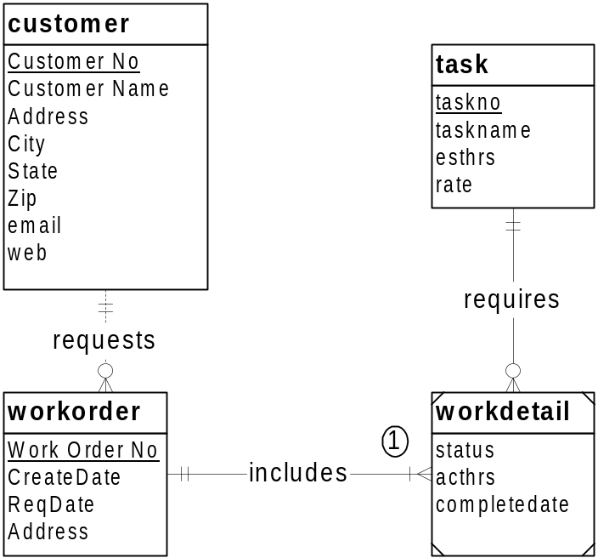

1. A workorder cannot be created unless at least 1 task is known.

Solution for revised requirements
- Workdetail could be a M-N relationship.
- Add an entity type for material. Connect material to work order in an associative entity type or a M-N relationship.
- Move esthrs from task to workdetail.

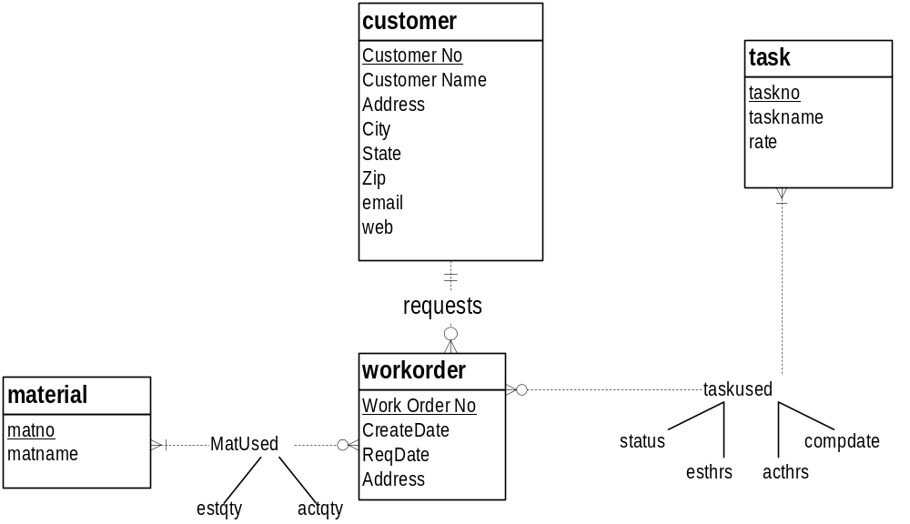
- For the Auto Dealership ERD shown in Figure 1, identify and resolve errors and note incompleteness in the specifications. Your solution should include a list of errors and a revised ERD. For each error, identify the type of error (diagram or design) and the specific error within each error type. Note that the ERD may have both diagram and design errors. Specifications for the ERD are presented in the following narrative.
Mountain High Quality Vehicles serves a metropolitan market with a medium size inventory of pre-owned cars and trucks. The vehicle inventory includes a variety of makes and models such as Acura, Chrysler, BMW, Cadillac, Ford, Chevrolet, Toyota, Honda, Mercedes-Benz, and more. A small staff manages the major functions of the business, purchasing, transporting, marketing, cleaning, maintaining, and selling the vehicles. They carefully inspect and certify the vehicles before they are available to the public for sale.
The dealership would like to develop an inventory management database to improve its tracking of vehicles, sales, and expenses. The dealership also would like to track information about its customers and car(s) sold to its customers.
- Vehicle Acquisitions: Periodically the owners attend auctions and purchase pre owned cars seeking reasonable prices and quality vehicles. They also purchase pre-owned vehicles from the wholesale market. The purchased vehicles are transported to the dealership and inspected for mechanical problems. Each vehicle is fixed and cleaned before being placed for sale.
- Vehicle Improvements: Apart from purchases, the dealership has additional expenses to prepare vehicles for market. The expenses typically involve transporting the purchased vehicle to the dealership, checking the vehicle for any potential problem, repairs and maintenance if necessary, marketing and cleaning.
- Sales Details: Customers purchase vehicles at the dealership. Each sale involves one customer even for married couples. Although customers can purchase more than one vehicle, each vehicle is recorded as a separate sale. When a sale is completed, the employee associated with the sale and payments are recorded. Typically, vehicles remain on the lot for a period of time before sales occur.
- Vehicle Details: The database tracks the unique vehicle identifier and vehicle identification number (VIN) to complete a sales transaction. The database also tracks vehicle characteristics such as make, model, year, mileage, exterior and interior colors, transmission type (automatic or manual), and number of cylinders (4 or 6).
- Customer Details: The database records the unique customer number, first and last names, address, city, state, postal code, primary phone number, and cellphone number.
- Expense Details: Each vehicle expense has a unique expense identifier, expense type, expense description, expense amount, expense paid date, account, and associated vehicle.
- Account Details: The database tracks account details such as a unique account identifier, account description, related expenses, and related payments.
- Payment Details: The database also tracks the vehicle sale (payment process). Each payment has a unique invoice number and payment method. The payment options are cash, credit card, or external line of credit as no financing is available at the dealership. Typically one payment is made per sale although multiple payments are sometimes made if a customer provides cash for part of the sale. If a customer is paying with a credit card, the payment includes the credit card number, expiration date, name on the credit card, and payment description. The employee that completed the sales transaction and vehicle should be recorded. The same employee works as sales associate and processes the payment to complete the sale. Each payment is associated with one account for company accounting purposes.
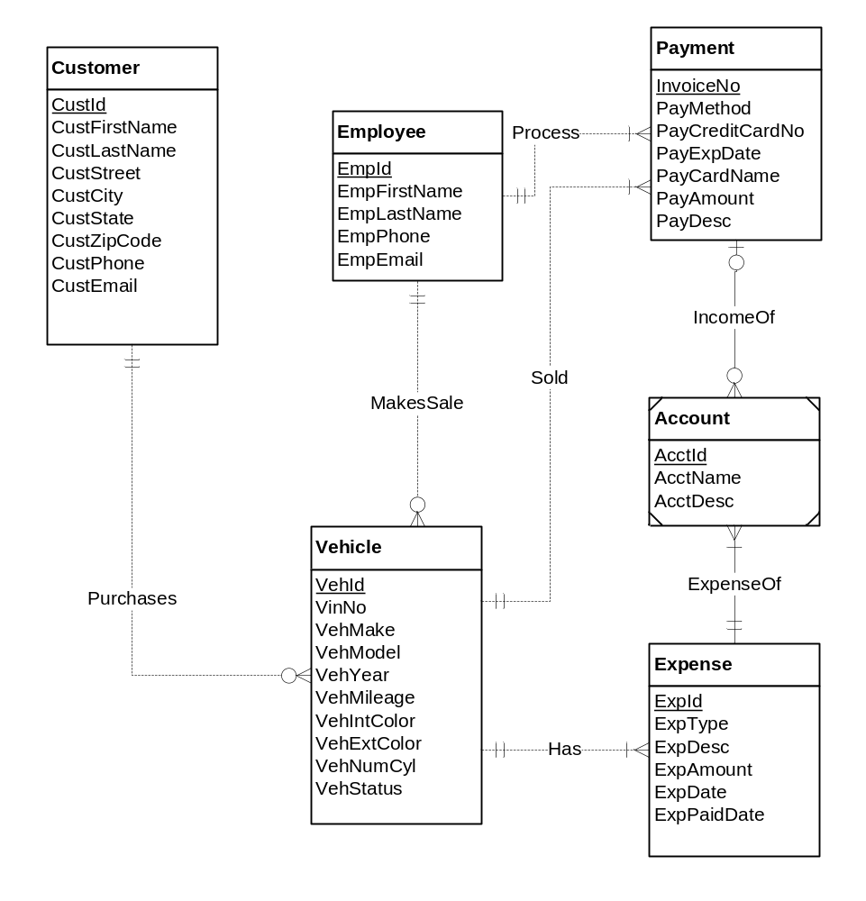
Figure 1: ERD for the Auto Dealership Database

Solution
The ERD contains the following errors.
- Diagram error 1: The identifying IncomeOf relationship must have a minimum cardinality of 1 for Account. Identifying relationships cannot be optional for the child entity type.
- Design error 1: Account should not be a weak entity type as the narrative indicates that AcctId is unique. If Account is a regular entity type, the IncomeOf and ExpenseOf relationships should be regular, not identifying.
- Design error 2: The cardinality of IncomeOf is reversed. The narrative indicates that each payment has an account and accounts are related to a collection of payments.
- Design error 3: The cardinality of ExpenseOf is reversed. The narrative indicates that each expense has an account and accounts are related to a collection of expenses.
- Design error 4: The minimum cardinality of MakesSale should be 0 for Vehicle. The narrative indicates that a vehicle can remain on the lot some days before a sale is made.
- Design error 5: The minimum cardinality of Sold should be 0 for Vehicle. The narrative indicates that a vehicle can remain on the lot some days before a sale and related payments are made.
- Design error 6: The Process relationship is redundant with the MakesSale and Sold relationships. The narrative indicates that the same employee makes the sale and processes the payment.
- Design error 7: The minimum cardinality of Purchases should be 0 for Vehicle. The narrative indicates that a vehicle can remain on the lot some days before a sale and related payments are made. Before sale, a vehicle is not related to a customer.
- Here is the revised ERD correcting these errors.

